New Medicare Cards are Coming!

Beginning April 2018
We want to remind you that starting April 2018, CMS will begin mailing new Medicare cards that will include a new Medicare Number. Medicare is removing Social Security Numbers from Medicare cards and beneficiaries will be assigned a randomly generated number that contains no personally identifiable information. The new ID card mailings will be staggered throughout the year, with completion expected by April 2019.

The switch to a unique ID number will help to reduce Medicare fraud and protect beneficiaries from identity theft. The new Medicare Beneficiary ID (MBI) will be 11 characters in length and is made up only of numbers and uppercase letters.

What Does this Mean for People with Medicare?
- People with Medicare may start using their new Medicare cards and MBIs as soon as they get them.
- Be sure to give your new MBI to your Doctor’s office, so that they can update your records.
- The effective date of the new cards, like the old cards, is the date the beneficiary was or is eligible for Medicare.

How Can You Prepare?
- You need to make sure their mailing address is up to date. If your address needs to be corrected, you can contact Social Security at ssa.gov/myaccount or 1-800-772-1213. TTY users can call 1-800-325-0778.
- Be aware of anyone who contacts you about new Medicare cards. CMS will never ask you to give personal or private information to get a new Medicare number and card.
- Please understand that mailing everyone a new card will take some time. Your card might arrive at a different time than your friend’s or neighbor’s.

SAMPLE:
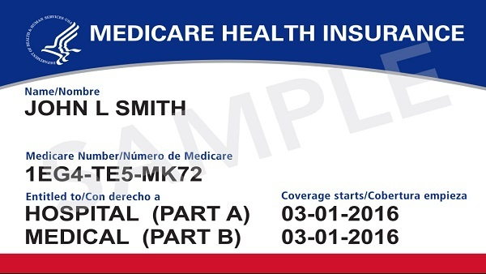
KEVIN J. KEEFE
610-258-9181 EXT. 118
KKEEFE@KWMMAIL.COM

